

**Faculty of engineering - Shoubra**

**Benha University**

|  |  |
| --- | --- |
| **Name** | **Ebrahem Ali Moustafa Mohamed** |
| **Edu.Email** | [ebrahim195013@feng.bu.edu.eg](mailto:ebrahim195013@feng.bu.edu.eg) |
| **B.N** | **13** |
| **Course** | **Computer** |
| **Course code** | **ECE001** |
| **Date** | **29/5/2020** |
| **Topic** | **Computer Engineering Role in COVID-19 Pandemic** |

**Computer engineering**

**Computer engineering** (CE) is a branch of [engineering](https://en.wikipedia.org/wiki/Engineering) that integrates several fields of [computer science](https://en.wikipedia.org/wiki/Computer_science) and [electronic engineering](https://en.wikipedia.org/wiki/Electronic_engineering) required to develop [computer hardware](https://en.wikipedia.org/wiki/Computer_hardware) and [software](https://en.wikipedia.org/wiki/Computer_software). Computer engineers usually have training in electronic engineering (or [electrical engineering](https://en.wikipedia.org/wiki/Electrical_engineering)), [software design](https://en.wikipedia.org/wiki/Software_design), and hardware-software integration instead of only [software engineering](https://en.wikipedia.org/wiki/Software_engineering) or electronic engineering. Computer engineers are involved in many hardware and software aspects of computing, from the design of individual [microcontrollers](https://en.wikipedia.org/wiki/Microcontroller), [microprocessors](https://en.wikipedia.org/wiki/Microprocessor), [personal computers](https://en.wikipedia.org/wiki/Personal_computers), and [supercomputers](https://en.wikipedia.org/wiki/Supercomputer), to [circuit design](https://en.wikipedia.org/wiki/Circuit_design). This field of engineering not only focuses on *how* computer systems themselves work but also how they integrate into the larger picture.

Usual tasks involving computer engineers include [writing software](https://en.wikipedia.org/wiki/Software_programming) and [firmware](https://en.wikipedia.org/wiki/Firmware) for [embedded](https://en.wikipedia.org/wiki/Embedded_system) [microcontrollers](https://en.wikipedia.org/wiki/Microcontroller), designing [VLSI](https://en.wikipedia.org/wiki/Very-large-scale_integration) [chips](https://en.wikipedia.org/wiki/Computer_chip), designing [analog](https://en.wikipedia.org/wiki/Analog_device) [sensors](https://en.wikipedia.org/wiki/Sensor), designing [mixed signal](https://en.wikipedia.org/wiki/Mixed-signal_integrated_circuit) [circuit boards](https://en.wikipedia.org/wiki/Circuit_board), and designing [operating systems](https://en.wikipedia.org/wiki/Operating_system). Computer engineers are also suited for [robotics](https://en.wikipedia.org/wiki/Robotics) research, which relies heavily on using [digital systems](https://en.wikipedia.org/wiki/Digital_systems) to control and monitor [electrical systems](https://en.wikipedia.org/wiki/Electrical_systems) like [motors](https://en.wikipedia.org/wiki/Electric_motor), [communications](https://en.wikipedia.org/wiki/Computer-mediated_communication), and [sensors](https://en.wikipedia.org/wiki/Sensor).

In many institutions of higher learning, computer engineering students are allowed to choose areas of in-depth study in their junior and senior year because the full breadth of knowledge used in the design and application of computers is beyond the scope of an [undergraduate degree](https://en.wikipedia.org/wiki/Undergraduate_degree). Other institutions may require [engineering students](https://en.wikipedia.org/wiki/Engineering_student) to complete one or two years of [general engineering](https://en.wikipedia.org/wiki/Engineering) before declaring computer engineering as their primary focus.

**Application Brief:**

**How can computer science contribute to stop the COVID-19 pandemic?**

The question of how computers can contribute to controlling the COVID-19 pandemic is being posed to experts in artificial intelligence (AI) all over the world.

AI tools can help in many different ways. They are being used to predict the spread of the coronavirus, map its genetic evolution as it transmits from human to human, speed up diagnosis, and in the development of potential treatments, while also helping policymakers cope with related issues, such as the impact on transport, food supplies and travel.

But in all these cases, AI is only effective if it has sufficient examples to learn from. As COVID-19 has taken the world into unchartered territory, the "deep learning" systems, which computers use to acquire new capabilities, don’t necessarily have the data they need to produce useful outputs. So we can use computer to know the all cases in the world and all deaths as shown in website that can help us to know the nature of covid-19 and how quickly it spreads around the world. Consequently I choose this application to show how computer helps us in this pandemic.

**Screenshots:**

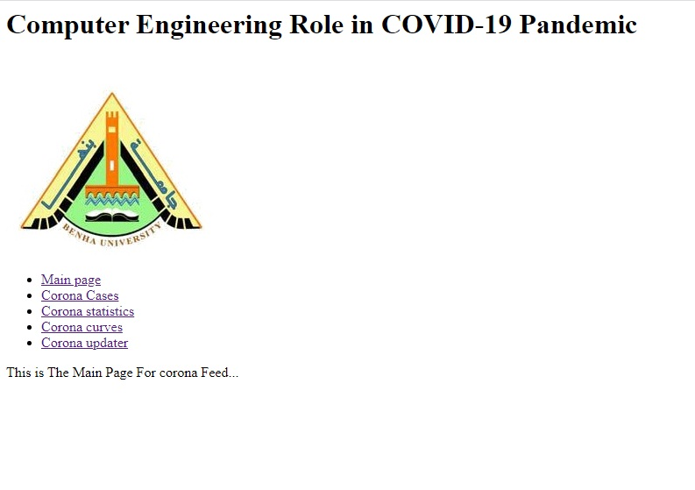

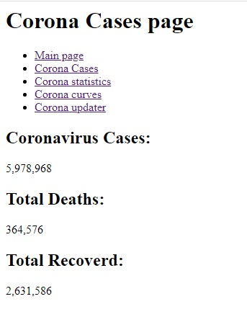



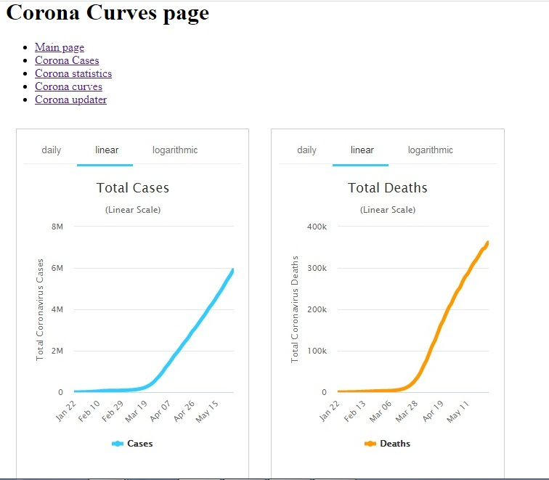

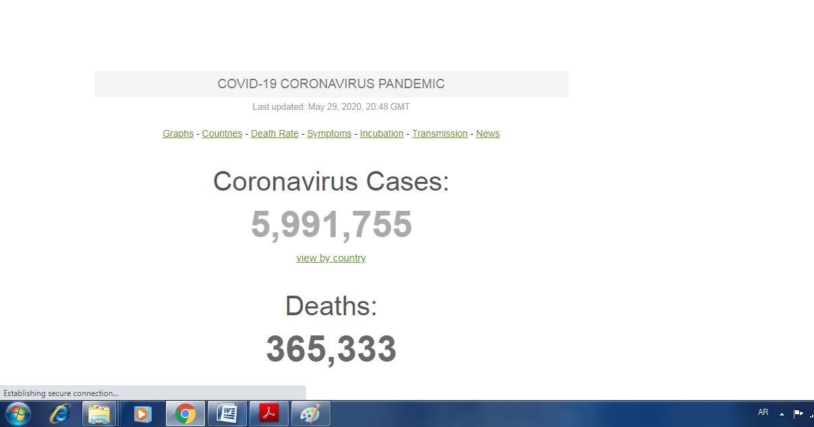

**Source Code:**

